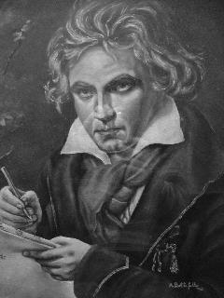
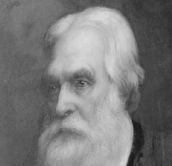
Join conductor Jon Mitchell of U.Mass/Boston, musicologist Luigi Bellofatto of Milano, Italy and amateur historian A. Richard Miller of Natick, for a music-punctuated evening about Ludwig von Beethoven's extraordinary music, including Jon Mitchell's reconstruction of two missing scores. Hear recorded excerpts from these works, and see extracts of them (in Beethoven's hand!) in an accompanying library exhibit.
Beethoven's great biographer, Alexander Wheelock Thayer, was a Natickite who served as U.S. Consul to Trieste from 1864 to 1882. Dick Miller will explore Beethoven's interesting Natick connection.
The Morse Institute Library presents:
A Beethoven Birthday Tribute
His Natick biographer,
and a new look at his work

Thursday, December 16, 2004
7:30 pm to 9:00 pm
Meeting Hall, Lower Level

This discussion is free and open to the public. Refreshments will be served.
For additional information, please call 508-647-6523.

The Morse Institute Library is located in downtown Natick on Rte. 135, one block east of the intersection of Rte. 27. The library is accessible to all.

